CS 201 DATA STRUCTURES
[Thursday, 12th April, 2012.] [FAST, NU LAHORE CAMPUS] [Time: 1.5 Hours]
[Midterm exam 2] SOLUTIONS [Total Marks: 35]

GOOD LUCK
QUESTION 1 (Marks 5+5+5)

Given the following binary search tree called letters:
letters:
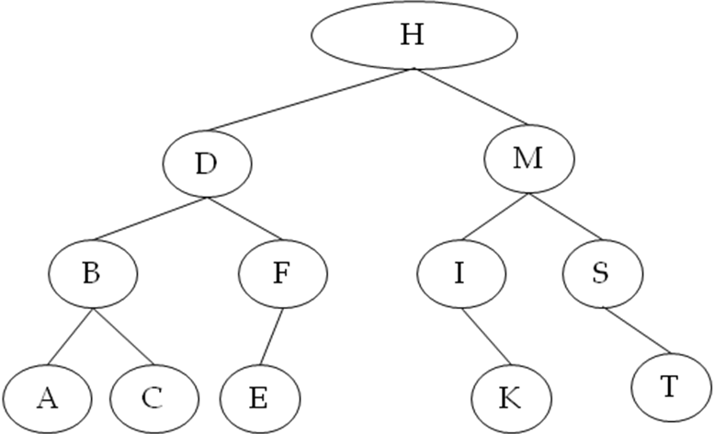

PART A: Delete the key H from the from the original letters tree shown above and draw it  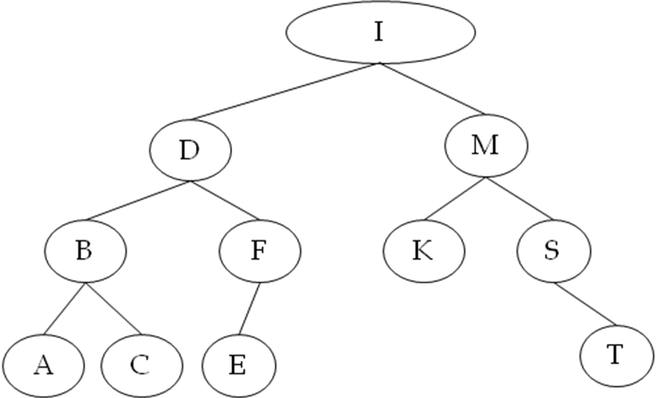  OR  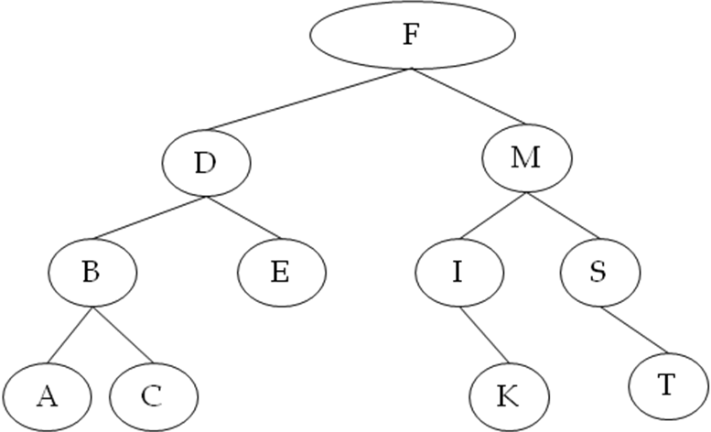 | PART B: Delete the key D from the original letters tree shown above and draw it  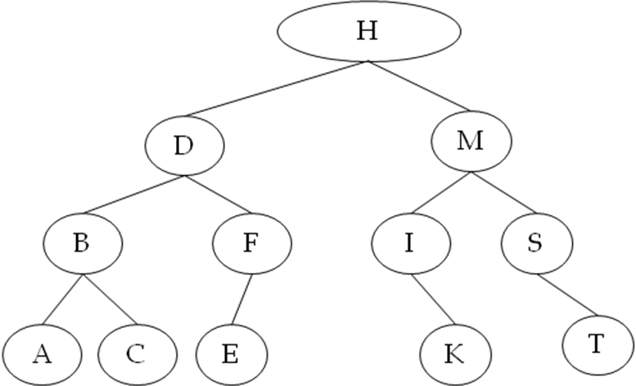  OR  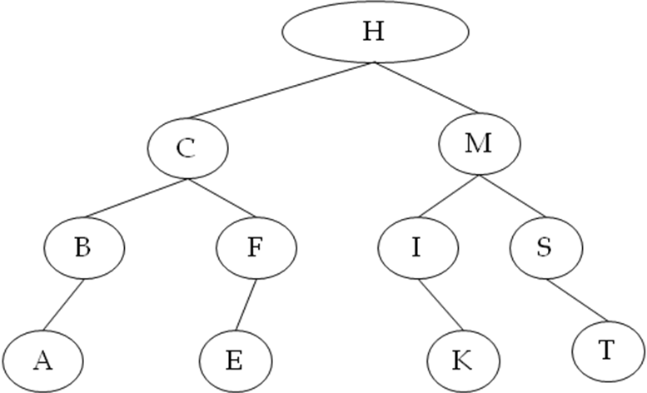

PART C: Given the following linked list and :
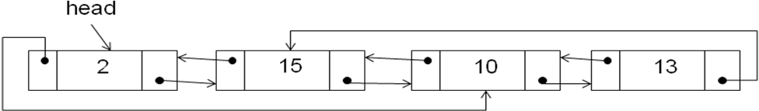
Draw the linked list after the following 3 operations are complete:
head->prev->next->next = head->next->next;
head = head->prev->prev;
head->prev = head

SOLUTION
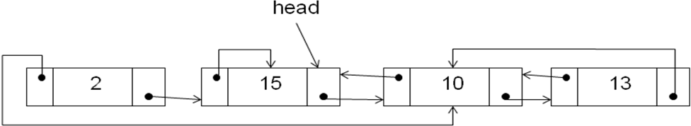

QUESTION 2 (Marks 10)
Suppose we have singly, sorted, linear, linked lists with a head pointer. Given two such sorted linked lists, construct a third linked list which is also sorted and contains all the nodes of the original two lists. If you use any other method then provide its implementation too. The complexity of your function must be O(m+n) where m is the total nodes in list 1 and n is the total nodes in list 2. The following declarations are provided:
You do not have to write the code for the implemented methods.
class Node  {  Node *next;  int Data;  friend class LinkedList;  }; | class LinkedList  {  public:  LinkedList(); //implemented  ~LinkedList(); //implemented  LinkedList(const LinkedList &L); //implemented  const LinkedList & operator = (const LinkedList &rhs); //implemented  LinkedList Merge(LinkedList &L); //you have to implement  //add any other method you like but implement it too  private:  Node *head;  };
You have to implement the merge function. An example is given below:
L1 is the following list:  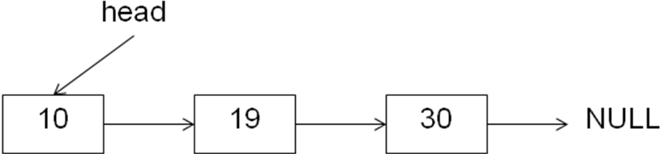 | L2 is the following list:  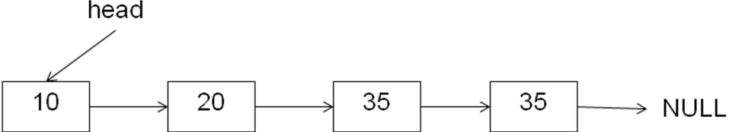

L3 = L1.merge(L2) should construct and return L3 as:
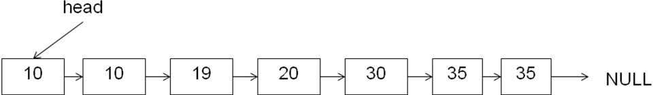

SOLUTION
NOTE: This is one possible solution and necessarily the best one. I am sure you can find a better solution

LinkedList LinkedList::Merge(LinkedList &L)
{
LinkedList ResultList;
Node *ResultPtr = NULL, *thisPtr = head, *LPtr = L.head;//ResultPtr will point to last link of list
//thisPtr will iterate through this
//LPtr will iterate through nodes of L

while (thisPtr || LPtr)
{
//create a new node for result list
Node *newNodeOfResult = new node;//will create the last node of result list
newNodeOfResult->next = NULL; //we will fill the data value later

//if head node does not exist
if (!Result.head)
{
Result.head = newNodeOfResult;
ResultPtr = Result.head;
}
else
{ //maintain the previous and next of of result list
ResultPtr->next = newNodeOfResult;
ResultPtr = newNodeOfResult;
}
if (!LPtr || (thisPtr && LPtr && (LPtr->Data > thisPtr->Data))
{ //if either LPtr is NULL or data in LPTR is greater than that of thisPtr
//then copy data of thisPtr in new node and advance thisPtr
ResultPtr->Data = thisPtr->Data;
thisPtr = thisPtr->next;

}
else
{ //will enter this case if either thisPtr is NULL or if data in thisPtr is greater than
//that of LPtr
ResultPtr->Data = LPtr->Data;
LPtr = LPtr->next;
}
}
return ResultList;
}

QUESTION 3 (Marks 10)
Write a recursive function PrintPath, to print the path of a node to the root in a binary tree (not necessarily a BST) having integer keys. For example, for the tree below the function should print: 17, 2, 1, 0, when the function PrintPath(17) is called.
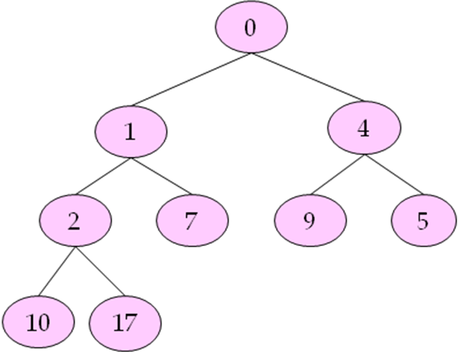 | You can assume there are no duplicate keys in the binary tree. You also have to implement the following public method that calls your recursive overloaded PrintPath method.  void BinaryTree::PrintPath(int value)

SOLUTION
NOTE: This is one possible solution and necessarily the best one. I am sure you can find a better solution
void BinaryTree::PrintPath(int value)
{
PrintPath(root,value);
}

bool BinaryTree::PrintPath(node *n,int value)
{
bool found = false;
if (n && n->data == value) //base case…value is found
{
found = true;
}
else if (n) //note that a base case is implicit here when n is NULL
{
found = PrintPath(n->left, value);
if (!found)
found = PrintPath(n->right,value);
}
if (found)
cout << n->data;

return found;
}

